NATIONAL UNIVERSITY OF
TECHNOLOGY


Computer Science Department
Advance Programming lab
LAB OEL # 01
Course Code: CS325
SUBMITTED TO:

PROFESSOR ZOHAIB MEHMOOD
SUBMITTED BY:
Name: MIAN SHAKAR AFZAL
Registration No: F23605073

QUESTION NO # 03
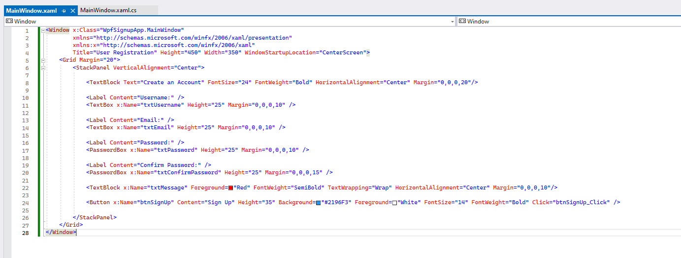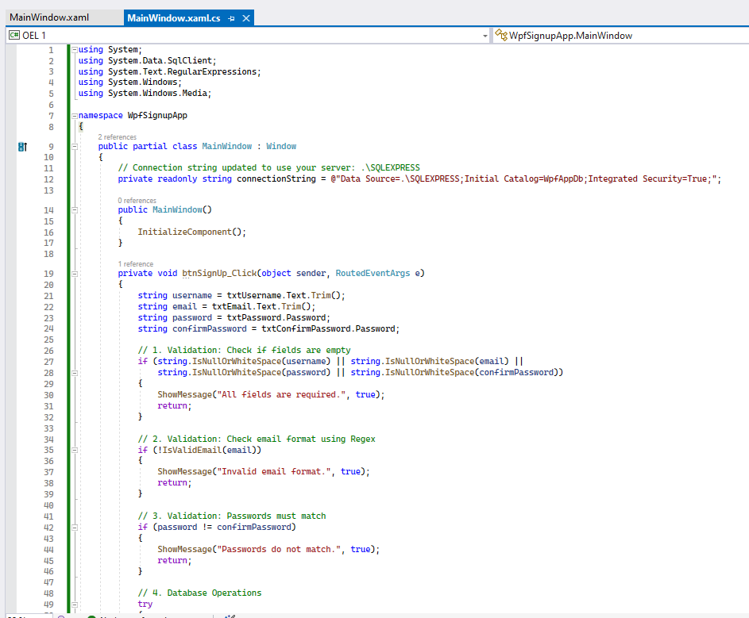
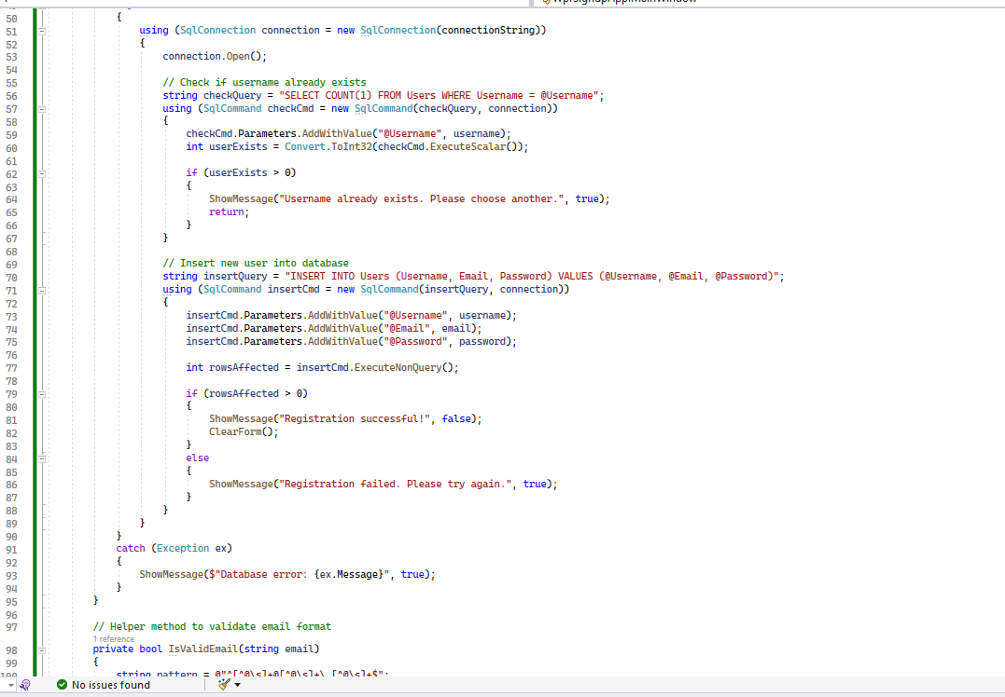

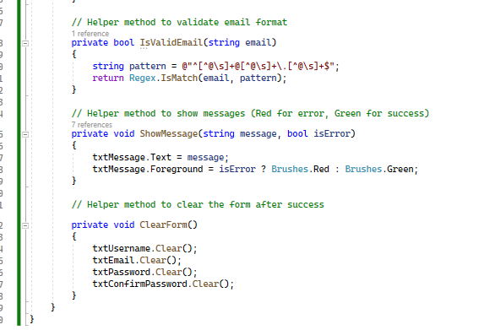

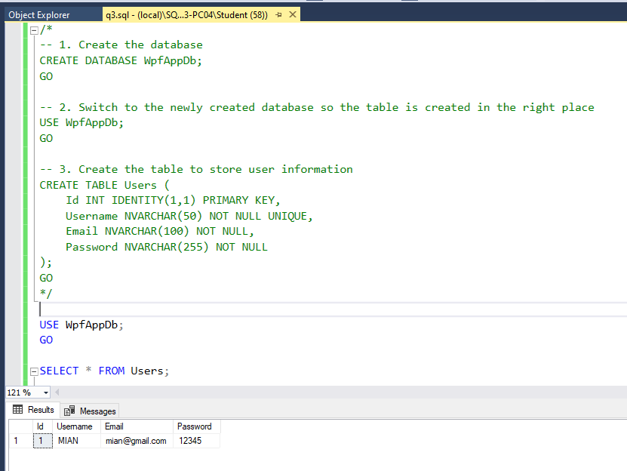

QUESTION # 02
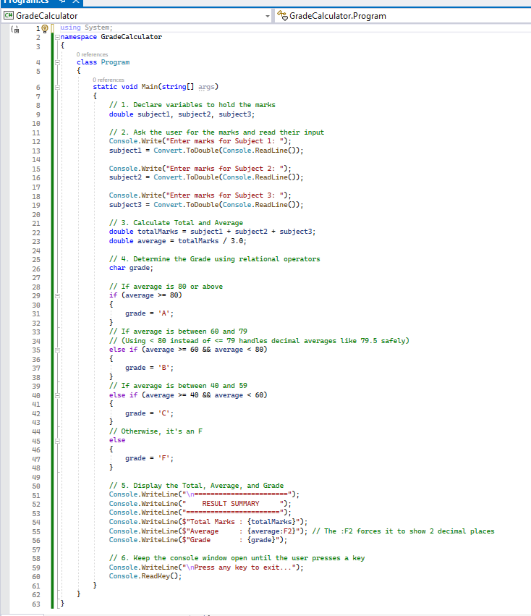
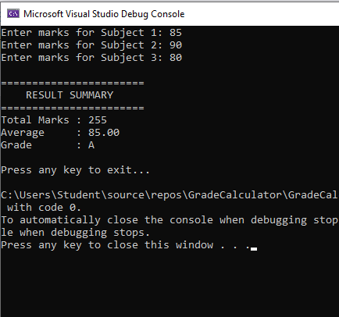

QUESTION # 1
